The classic 3 mile Sunday Social run (5 km)
The route is along clear paths on the Common on major paths. A few places on the route could get muddy after wet weather but not badly so. The route described starts and finishes at the Windmill.

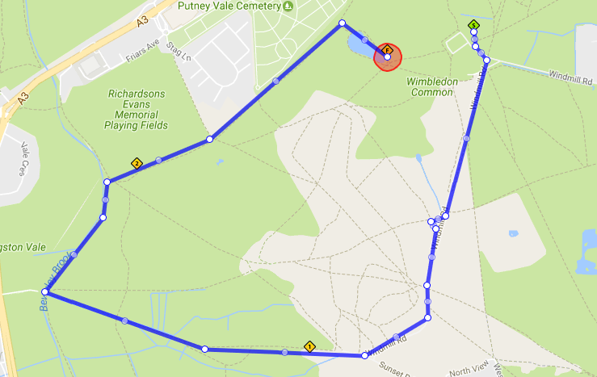
One potential 3 mile Social route.
A
B
C
D
E
Generally the group can run at their own speed but we gather at certain points (e.g. [A], [B]) so that the group stays together overall. Runners can either stop when they get to each point or turn and jog back to back marker if they want less time stopped.
[S] = Start on Grass in front of Windmill
Run along main path towards Wimbledon until grass on right at [A]
[A] = Active stretching (leg flicks, knee raises, etc)
Continue to end of main path
[B] = End of Windmill Rd path
Turn right and down gravelly hill
[C] = Before Bridge over brook
Turn right along path alongside Brook
[D] = By Wooden Bridge over Brook
Turn right across edge of field
By now some of group may be walking and others full of running and so I often send
walkers directly across edge of field and others around the hedge around the memorial or anything to give some a bit extra to run.
[E] = corner of field by War Memorial
Turn left uphill and along path to Pond
[F} = pond beneath Windmill – Final Stretch here
Walk up to Windmill to finish
Jeff Hoadley, November 2020

