The classic 7-mile Sunday Social run (11 km)
The route is along clear paths on the Common on major paths. A few places on the route could get muddy after wet weather but not badly so. The route described starts and finishes at the Windmill.
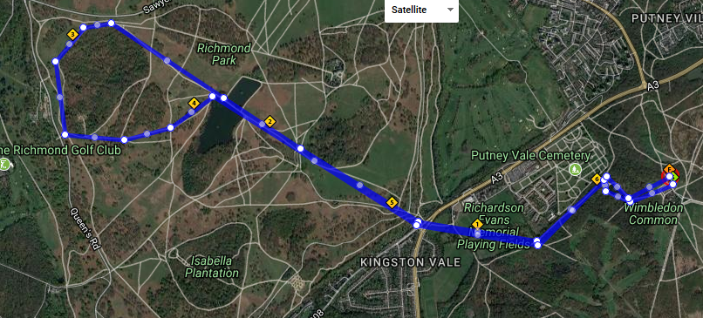
A
D

E
A
B
C

One potential 7 mile Sunday route.
Generally the group can run at their own speed but we gather at certain points (e.g. [A], [B]) so that the group stays together overall. Runners can either stop when they get to each point or turn and jog back to back marker if they want less time stopped.

[S] = Start on Grass in front of Windmill
Run down past pond to [A]
[A] = Turn left along path at bottom of pond
Continue to end of main path
[B] = Memorial
Run across field and cross A3 (CARE!) into Richmond Park Robin Hood Gate
[C] = Robin Hood Gate
Run up grass path on Spankers Hill and along path between Pen Ponds
[D] = Far side of Pen Ponds
Tell runners to run directly up hill ahead and then around Sidmouth Wood until they reach tarmac path at [E]. Tell them to keep Wood fence a few metres to the left all the way around.
[E] = tarmac path far corner of Sidmouth Wood
Turn left onto tarmac path and then grass path down to ponds

Further notes:
Once back at ponds follow the same route back.
Jeff Hoadley, November 2020

