**Wimbledon Common War Monuments Route (4.8 miles / 7.7 Km)**

**A circular route, starting and finishing at Windmill museum**

Garmin route: <https://connect.garmin.com/modern/course/46247279>

A circular route, starting and finishing at Windmill museum and taking in all 5 war related monuments on the Common and Putney Heath. The route described starts and finishes at the Windmill but can be joined at any point. The route is along clear paths on the Common and mainly on major paths. A few places on the route could get muddy after wet weather but not badly so. The route does pass across the golf course at one point - please watch out for golfers.

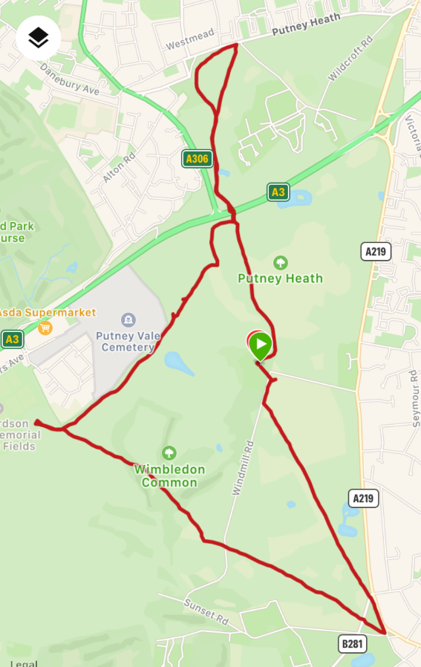

**Start**: at the Windmill museum and follow the ‘Windmile’ then take the first path on the left, heading South across the Plain towards Wimbledon Village.

**[1]:** **Wimbledon Village War Memorial**

The Memorial was built in 1919 to commemorate local men who lost their lives in the First World War

and further inscriptions were added later to commemorate those lost in the Second World War.

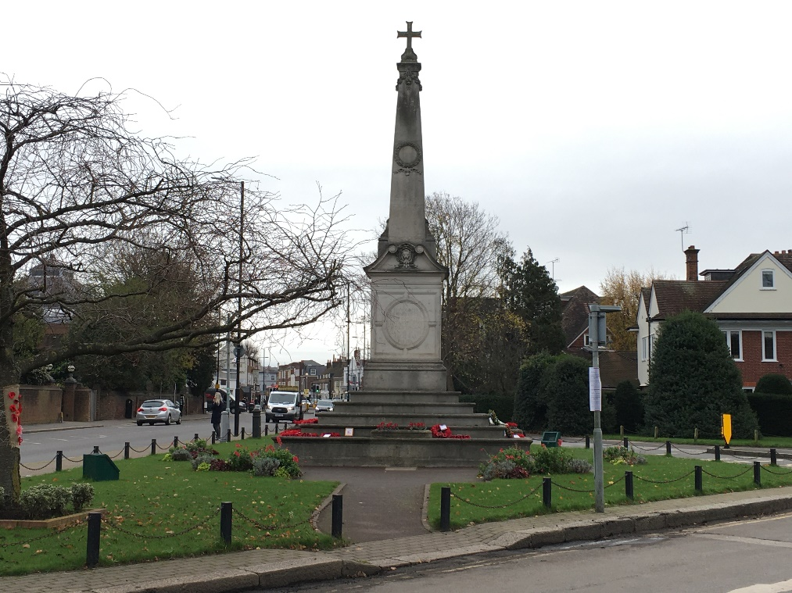

**[2]: Kings Royal Rifle Memorial (KRR Stone)**

The KRR Stone was erected to commemorate men of the King’s Royal Rifle Corps who passed through

the Wimbledon Common transit camp during the First World War.

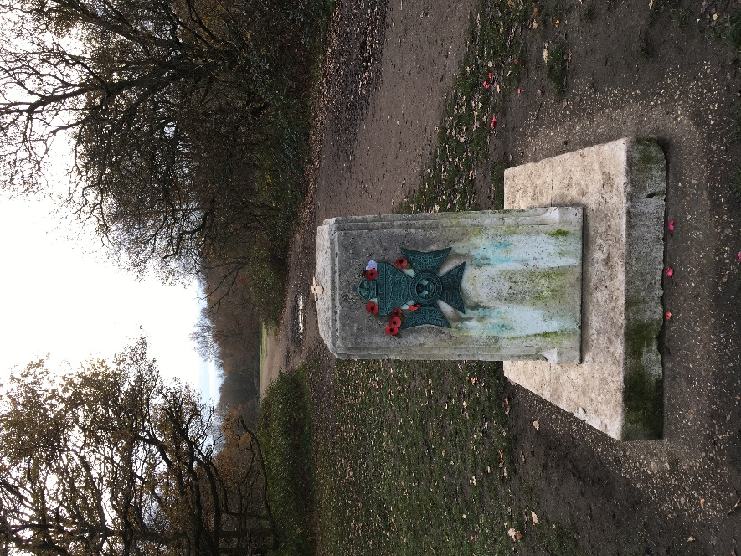

**[3]: Richardson Evans Playing Fields - First World War Memorial**

In the 1920’s, the Conservators were able to acquire an additional 42 acres of land. The site, which

formed part of Newlands Farm, is now called the Richardson Evans Memorial Playing Fields. Five acres of this land was dedicated and landscaped as a War Memorial Grove. At the heart of the site is a granite monument, inscribed with the names of local men who gave their lives for their country in the Great War of 1914-1918.

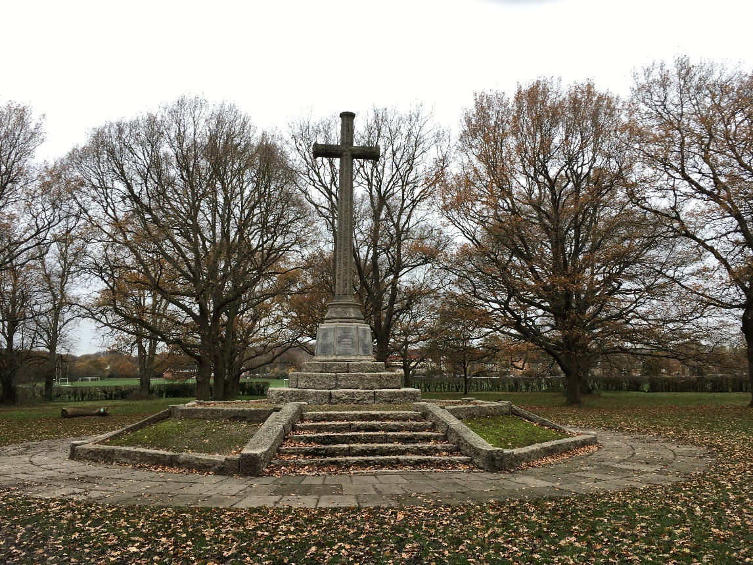

**[4]: Tangier Stone (Queens Royal Rifles)**

The Tangier Stone was erected in 1961 to commemorate the 300th anniversary of the first parade of the

Tangier Regiment of Foot (now the Queen’s Regiment). It is situated north of the Roehampton Hills.

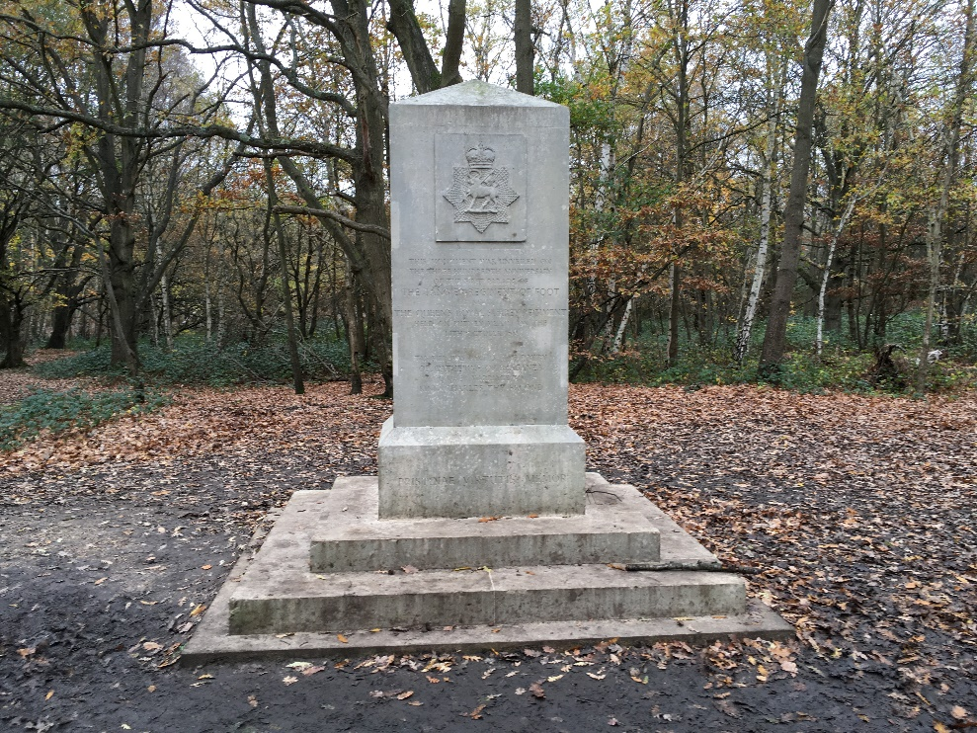

**[5]: Roehampton War Memorial**

The original war memorial that stood on this site was badly damaged by enemy action during the

Second World War. The present memorial was erected in 1952.

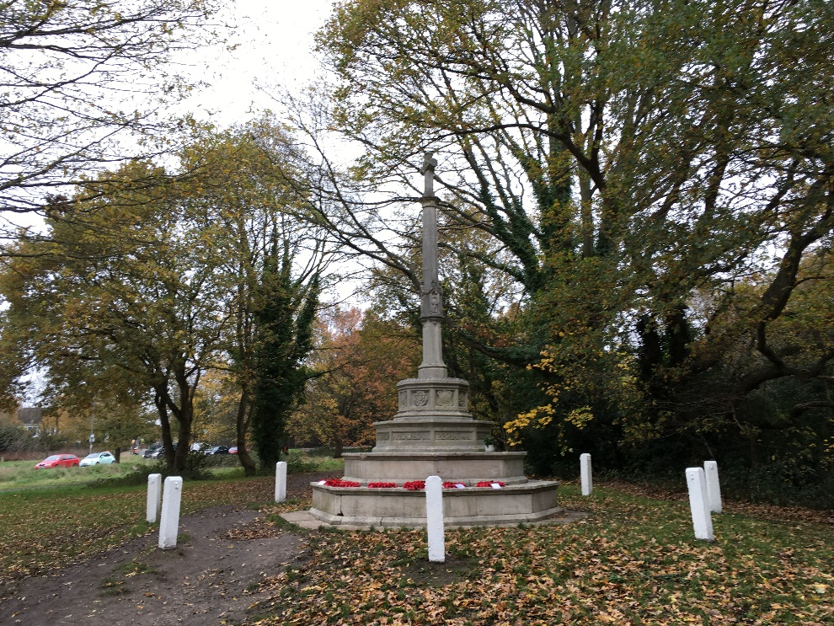

Continue alongside Putney Heath Road, then cut back across Putney Heath towards the Windmill.

References

https://www.wpcc.org.uk/families-education/memorial-stones

With thanks to Jeff Hoadley for creating this route.